



Module Code & Module Title
Level 5 – Network Operating Systems

Assessment Type
Logbook 4
Semester
2023/24 Spring/Autumn

Student Name: Aayush Wanem Limbu
London Met ID: 22072043
College ID: npo5cp4a220010
Assignment Due Date: Saturday, November 25, 2023
Assignment Submission Date: Saturday, November 25, 2023
Submitted To: Enjina Ghimire
Word Count (Where Required):1450

I confirm that I understand my coursework needs to be submitted online via Google Classroom under the relevant module page before the deadline in order for my assignment to be accepted and marked. I am fully aware that late submissions will be treated as non-submission and a mark of zero will be awarded.

Table of Contents
1. Host a Static website in windows server 2022. 1
1.1 Aim 1
1.2 Objectives 1
1.3 Required Tools and concepts. 2
1.4 Download and Extraction of website template in the correct path 3
1.5 Steps for configuring windows serve to host a website. 9
1.6 Configuring the ISS manager. 20
1.7 Conclusion 26

Table of Figures
Figure 1Opening web browser. 3
Figure 2 Opening the website to download template. 4
Figure 3 Select and Download the template. 5
Figure 4 Download Completion of Website. 6
Figure 5 Extracting the downloaded .zip folder. 6
Figure 6 Adding extracted folder to C drive. 7
Figure 7 Verifying extraction. 8
Figure 8 Add roles and features on server manager. 9
Figure 9 Add roles and features prompt 1. 10
Figure 10 Selecting Role based or Feature-based Installation. 11
Figure 11 Selecting our server from the server pool. 12
Figure 12 selecting web server (ISS) feature. 13
Figure 13 Adding feature. 14
Figure 14 Description about our Feature. 15
Figure 15 Select Role Services. 16
Figure 16 Confirm install selection step 1. 17
Figure 17 Figure 16 Confirm install selection step 2. 18
Figure 18 Installing the actual service. 19
Figure 19 Selecting the ISS manager. 20
Figure 20 ISS manager 21
Figure 21 Selecting the Sited folder. 22
Figure 22 Clicking on Add Website icon. 23
Figure 23 website configuration. 24
Figure 24 final testing. 25

Host a Static website in windows server 2022.

Aim
In this logbook at first, we will learn how to install server roles and features that helps us to host a basic static frontend website from our windows server 2022 and view it in a web browser.

Objectives
- Make a step-by-step documentation of downloading and hosting a static website.
- Learn how a website is hosted in a windows server 2022.
- Downloading a basic frontend website
- Adding the website to the correct folder(path)
- Installation of Roles and Features.
- Web server role installation
- ISS manager configuration
- Adding our new website
- Viewing website in the web browser

Required Tools and concepts.
Tools:
Windows Server 2022: A stable and updated installation of Windows Server 2022 with enough ram and storage with internet connectivity.
Web browser: A updated web browser for downloading the web site template.
Server Manager Dashboard: Access the dashboard for efficient management of server roles and features.
Internet Information Services (IIS) Manager: We will use the IIS Manager for web server configuration.

Concepts:
Web Hosting Basics: Understand fundamental concepts of hosting a website on a server.
Roles and Features: Familiarize yourself with Windows Server 2022 roles and features necessary for web hosting.
Web Server (IIS): Understand the importance of the Web Server (IIS) role in hosting web applications.
Website Structure: Comprehend the structure of a website, including folders, files, and their organization.
Domain and Hostname: Understand the concepts of domain names and hostnames for website identification.
Path and Directory: Learn the terminology related to file paths and directories in the context of website hosting.

1.4 Download and Extraction of website template in the correct path
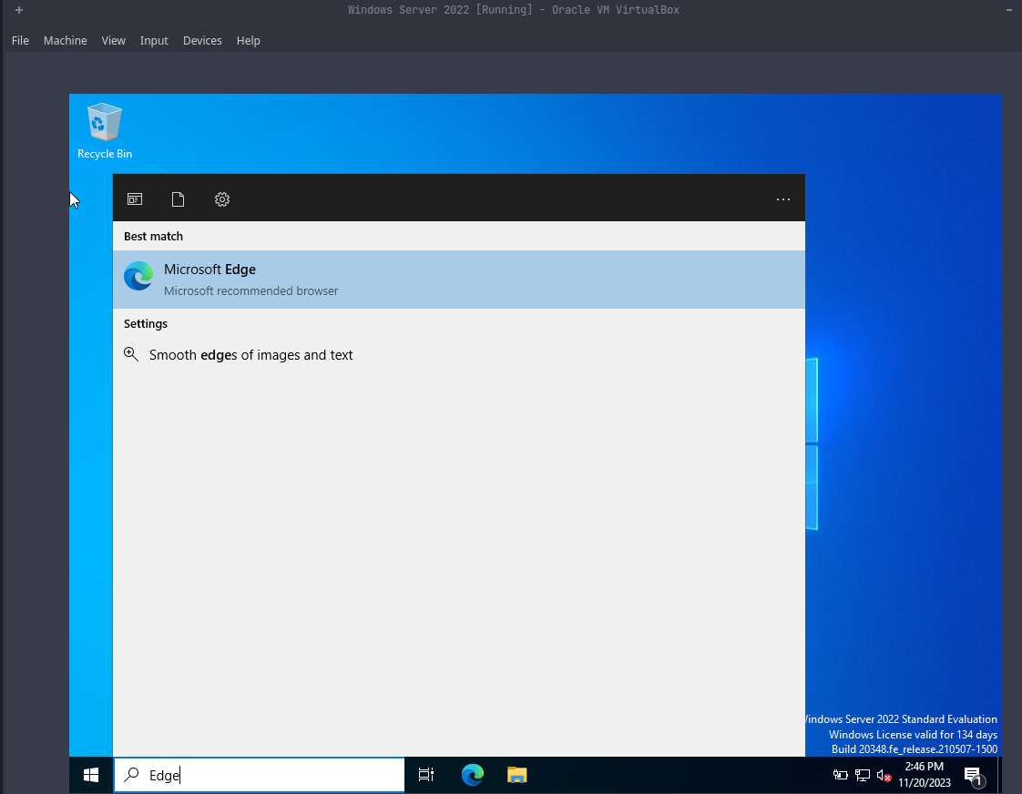
On our windows server virtual machine, we will first have to download the website template and extract it into the correct path (C:// drive) for hosting our website. Our first step is to open a web browser.
Figure 1Opening web browser.

After the web browser has been opened successfully our second step is to download the website template using a web browser from www.free-css.com.
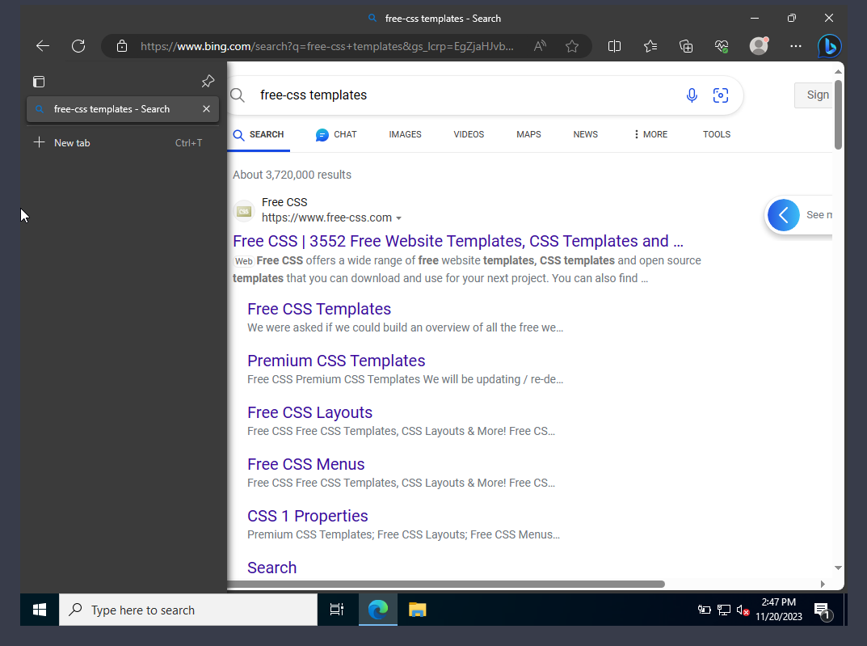
Figure 2 Opening the website to download template.

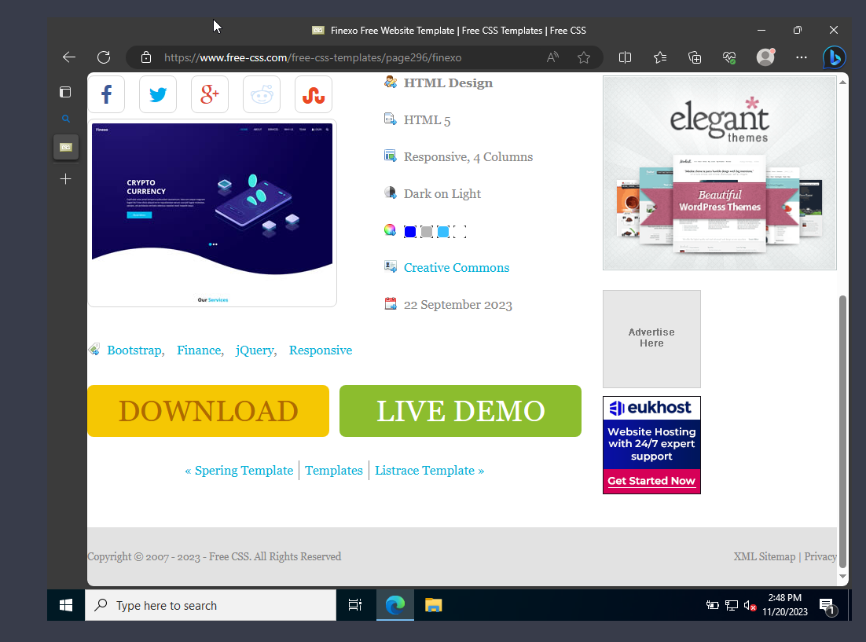
Our third step is to select the desired website template from the free library and download the whole website template.
Figure 3 Select and Download the template.

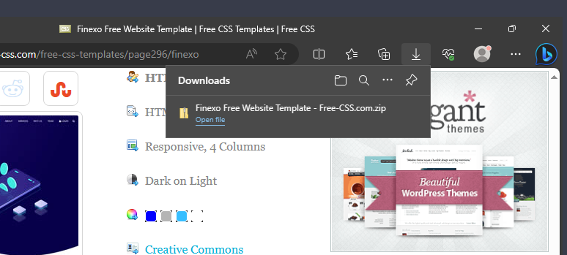
After selecting the desired template and downloading it we have to now extract our downloaded website zip folder directly to the C:\\ drive or we can also extract it to the download folder at first and we can copy it to the C:\\ drive.
Figure 4 Download Completion of Website.

Now we will open the file manager and extract the downloaded folder for that we will right click the downloaded folder and select the Extract all option.

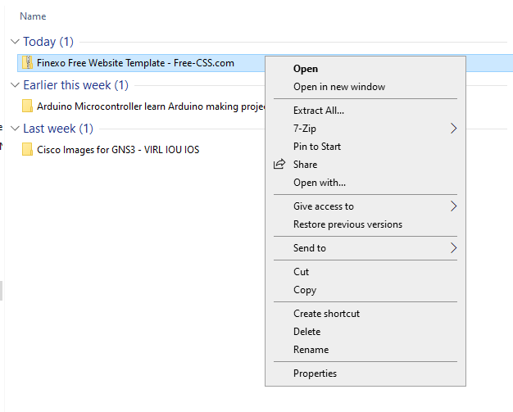
Figure 5 Extracting the downloaded .zip folder.
Now after clicking the Extract all option now, we have to choose where to store the extracted folder, I have directly changed the path of the extracted folder to be added in the C:\\ drive instead of the download folder. The highlighted rectangle below shows the folder destination path.
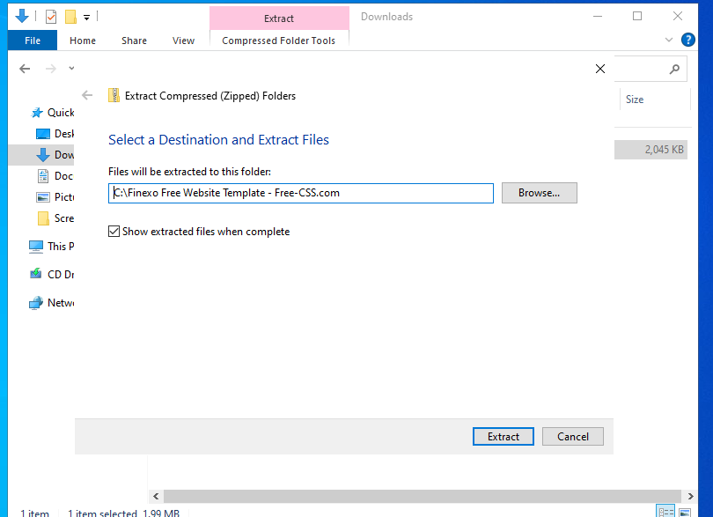
Figure 6 Adding extracted folder to C drive.

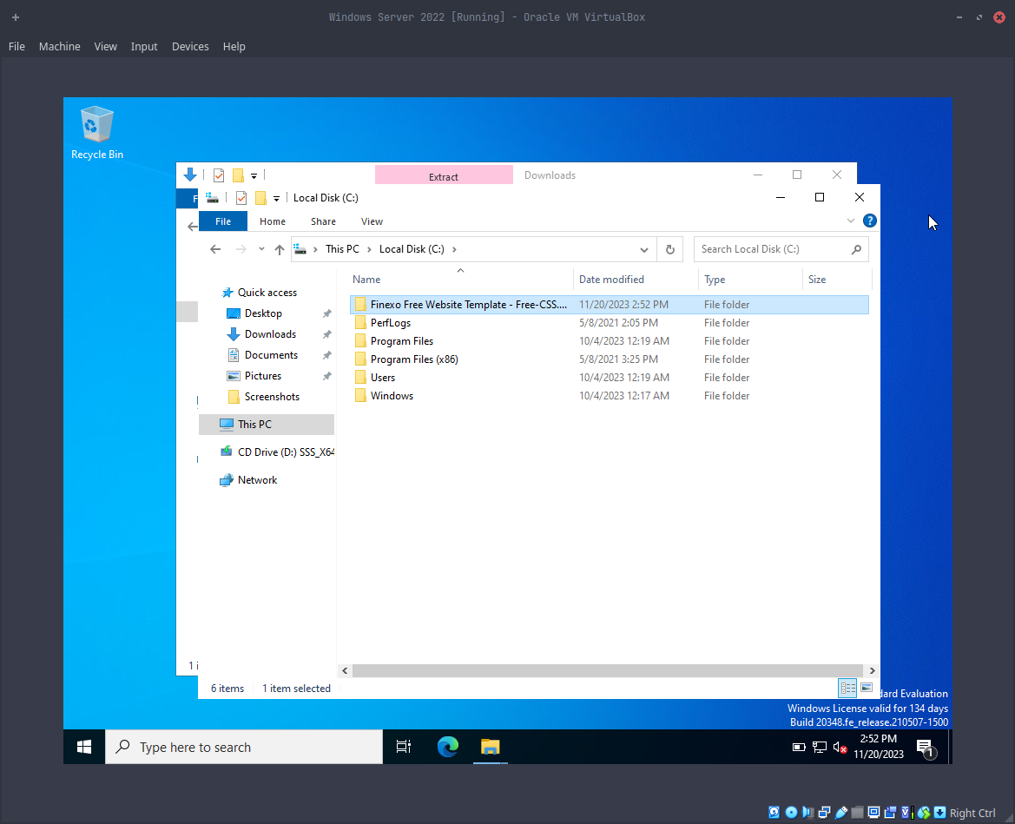
We can verify that the folder we extracted is in C drive.
Figure 7 Verifying extraction.

With this now we have successfully completed the download and extraction phase now we have to configure the windows server to host our website.

1.5 Steps for configuring windows serve to host a website.
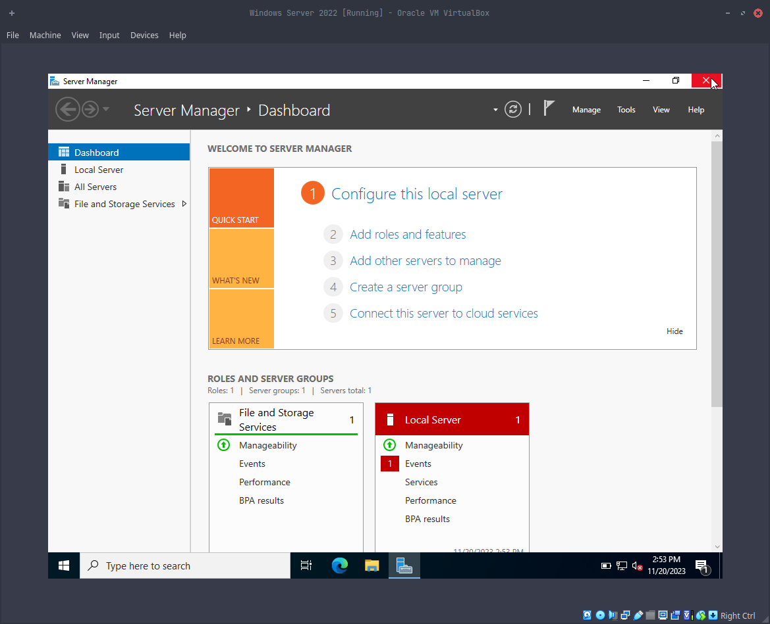
Our first step is to open the server manager dashboard and select the Add roles and features option.
Figure 8 Add roles and features on server manager.

After this a new prompt will be shown we just have to click next.
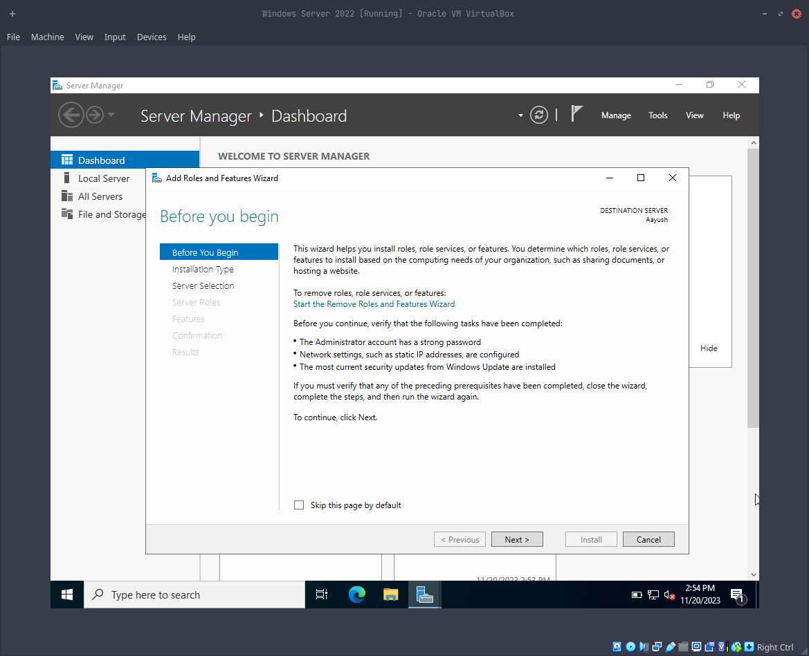
Figure 9 Add roles and features prompt 1.
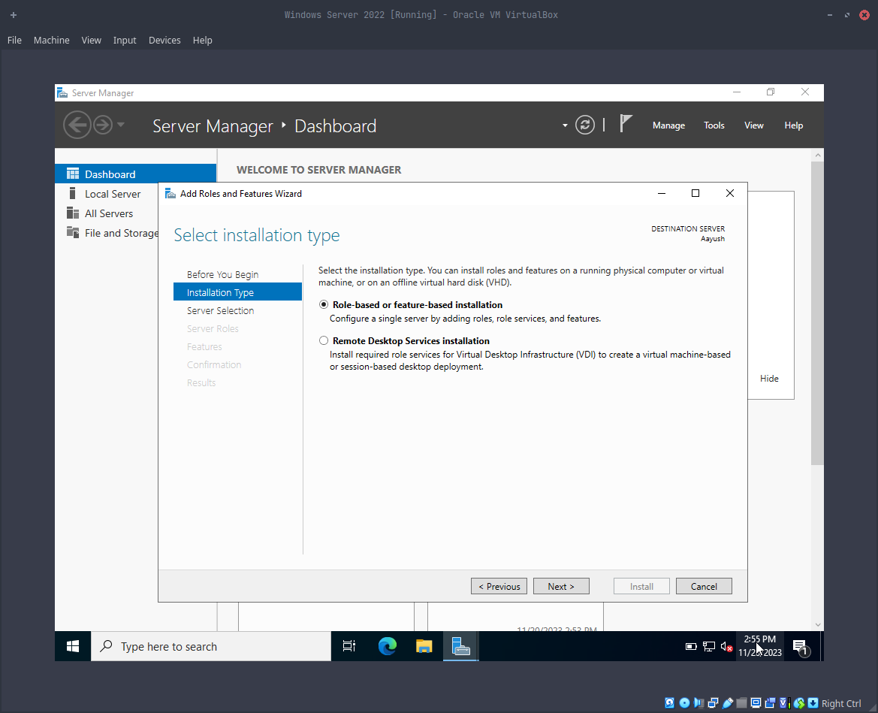
After that now we have to select the Role based or Feature-based Installation option and click next.
Figure 10 Selecting Role based or Feature-based Installation.
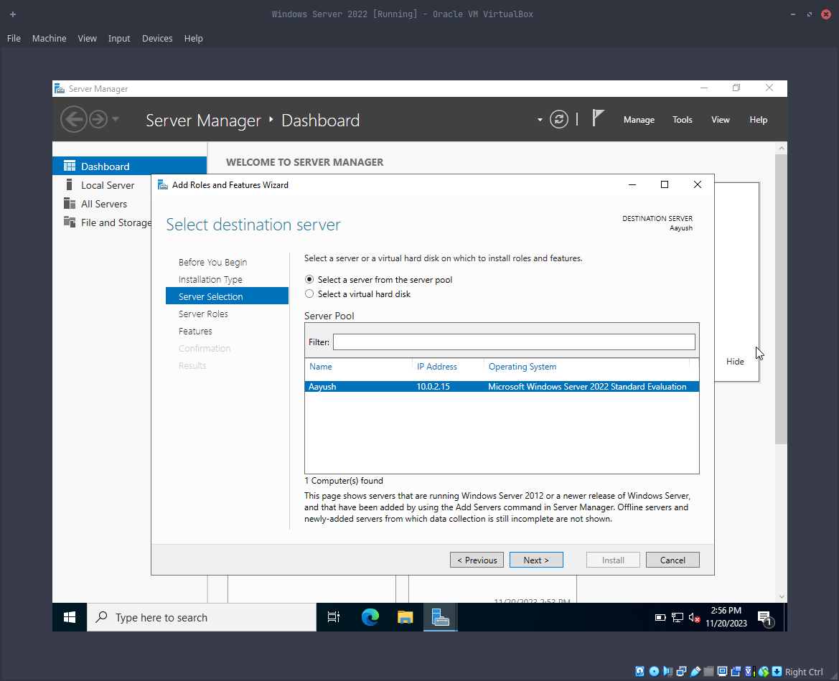
In the third step, we have to select our server from the server pool list. Since there is only one server, only that server’s name will be displayed for us to choose. After choosing the desired server now click enter.
Figure 11 Selecting our server from the server pool.
Our fourth step is to select the appropriate feature from the list of features, we will select the web server (ISS) feature and click next.
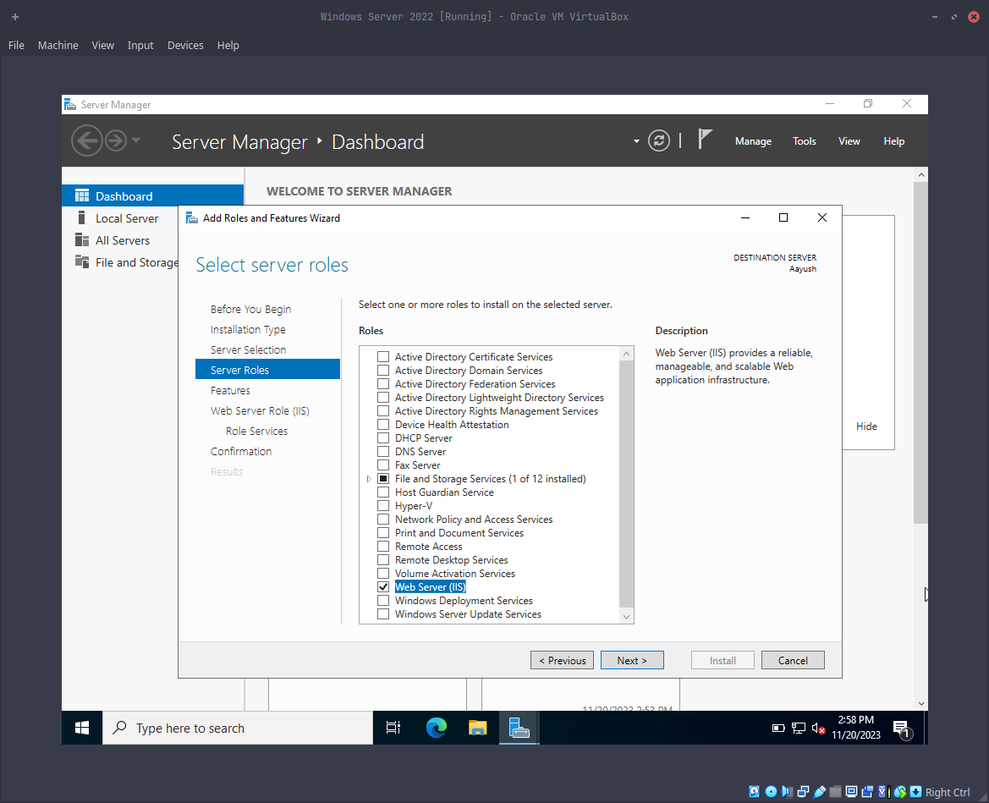
Figure 12 selecting web server (ISS) feature.
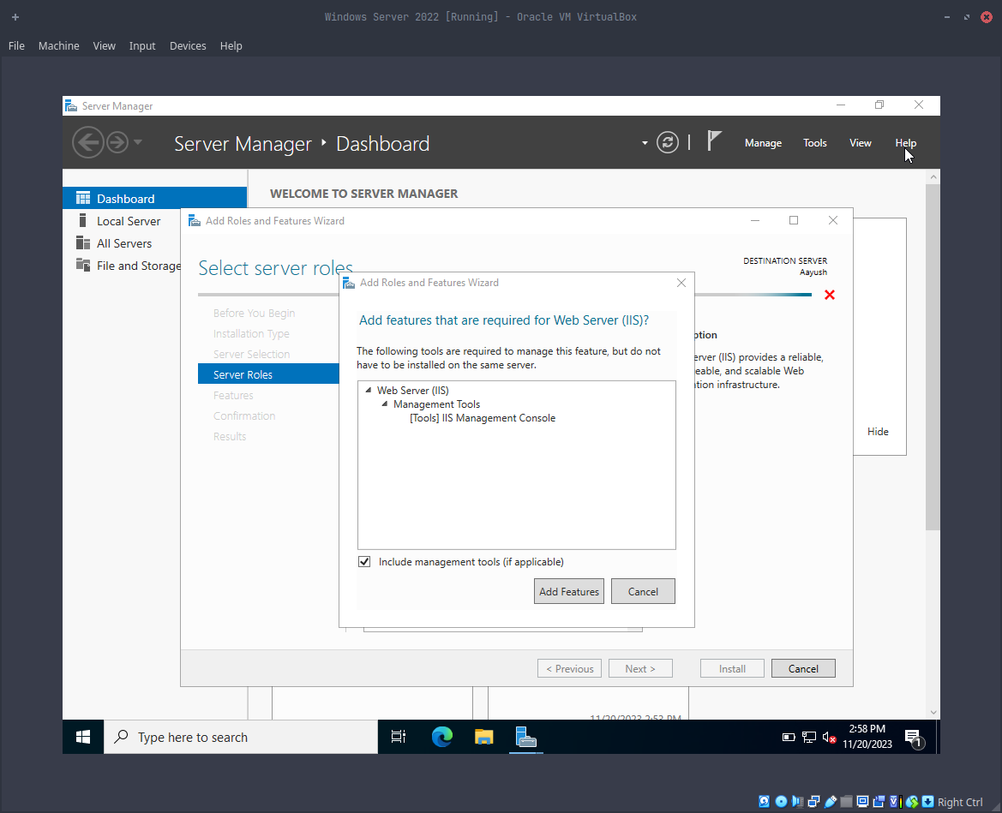
After that step a new prompt will be shown showing the list of features that we ticked marked on, after verifying that all features that we clicked on are there we can Add Features.
Figure 13 Adding feature.
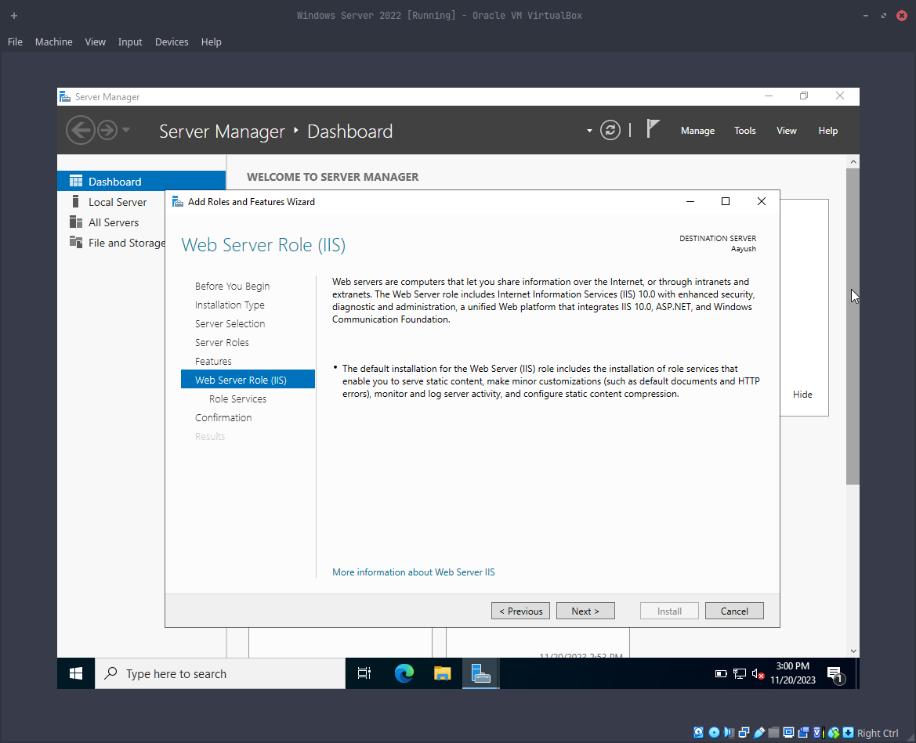
On the next step we can see that there is a description about the type of feature that we are trying to install, we can simply click next and move ahead to the next step.
Figure 14 Description about our Feature.
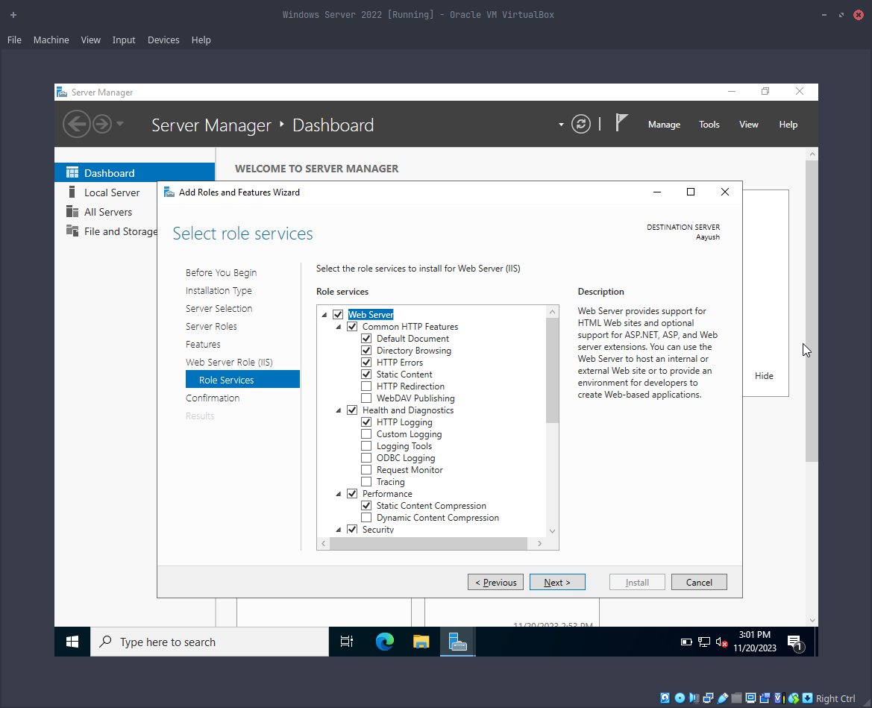
Now on the next step we will have to select the role services, we will now stick with the default role services with now.
Figure 15 Select Role Services.

On the next step we will have to tick the restart the destination server automatically required option and click yes on the confirmation prompt.
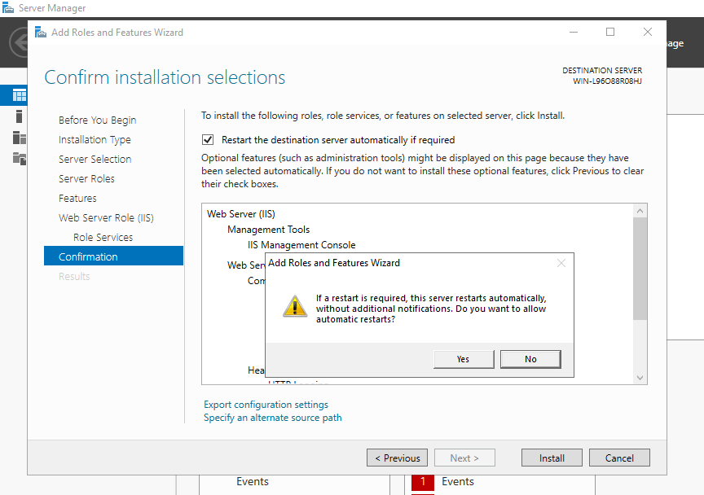
Figure 16 Confirm install selection step 1.

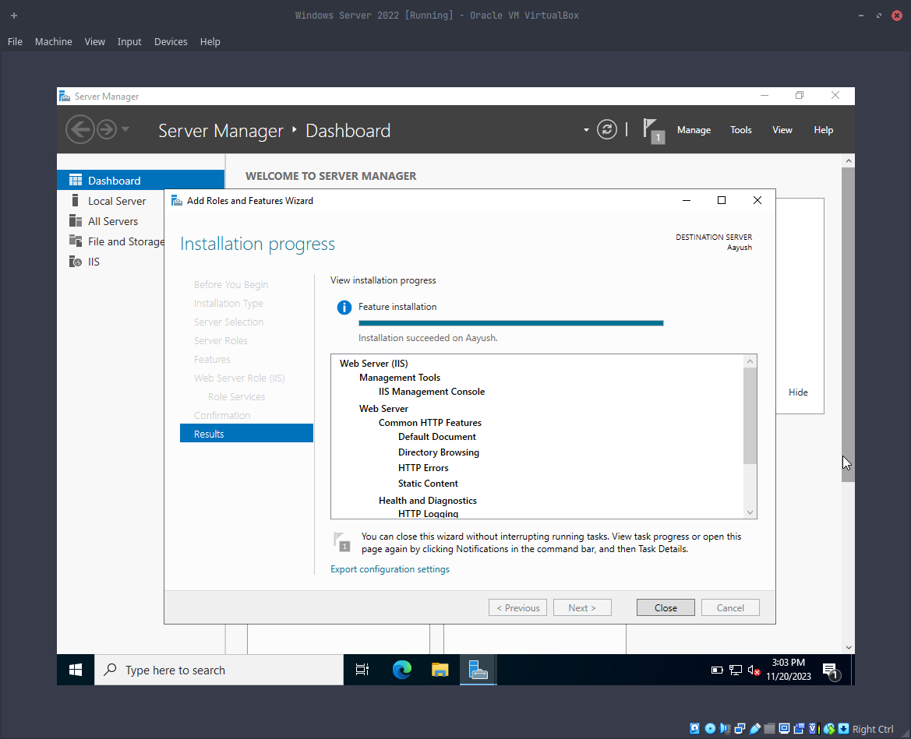
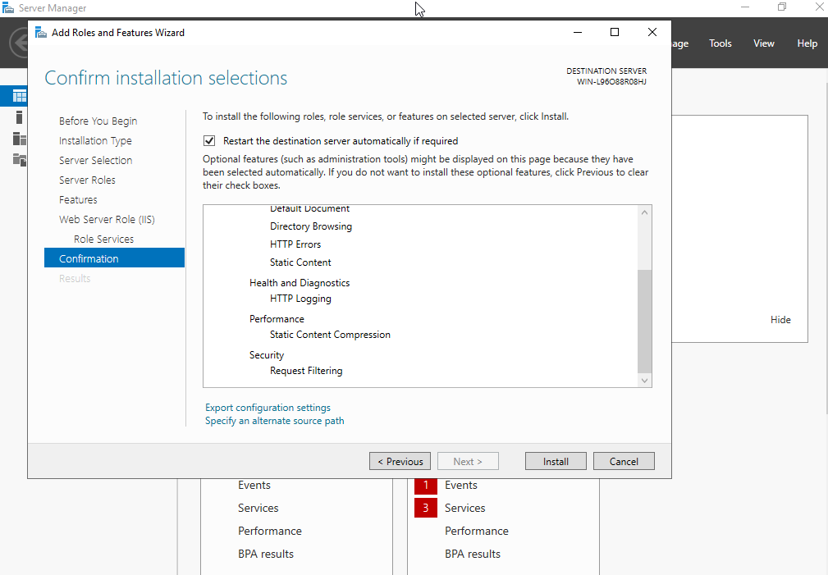
On this step we will have to click the install button to install our selected feature.
Figure 17 Figure 16 Confirm install selection step 2.
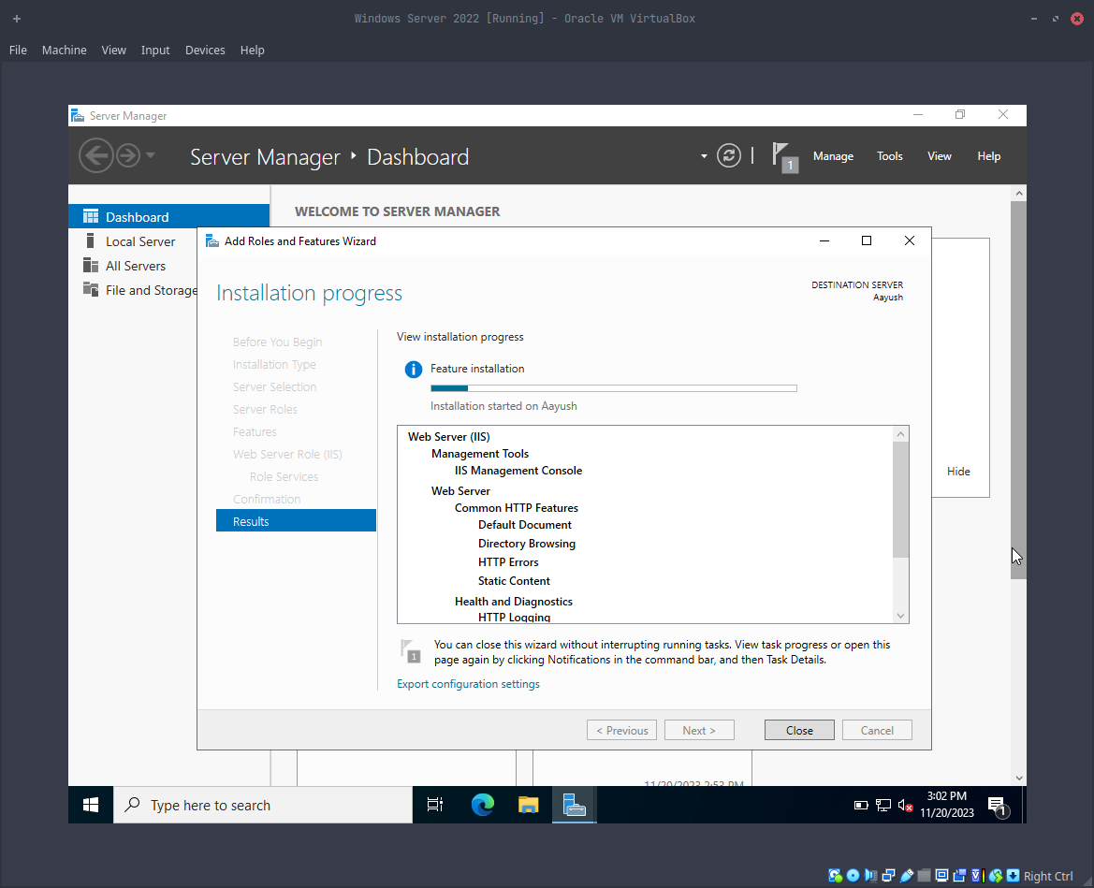
We can see that the feature is being installed and once the targeted feature is installed it will automatically restart if necessary.
Figure 18 Installing the actual service.

Once the installation is completed it will say installation completed on server name. We can now close the installation window and move to the next step.

1.6 Configuring the ISS manager.
The next process is to configure the ISS manager for that we have to:
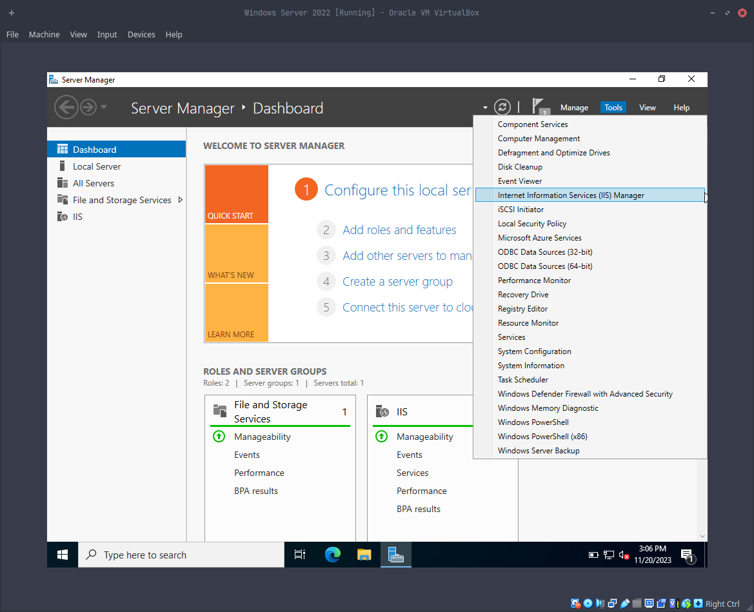
On the server manager we have to select the tools option and select Internet Information Services (ISS) Manager.
Figure 19 Selecting the ISS manager.

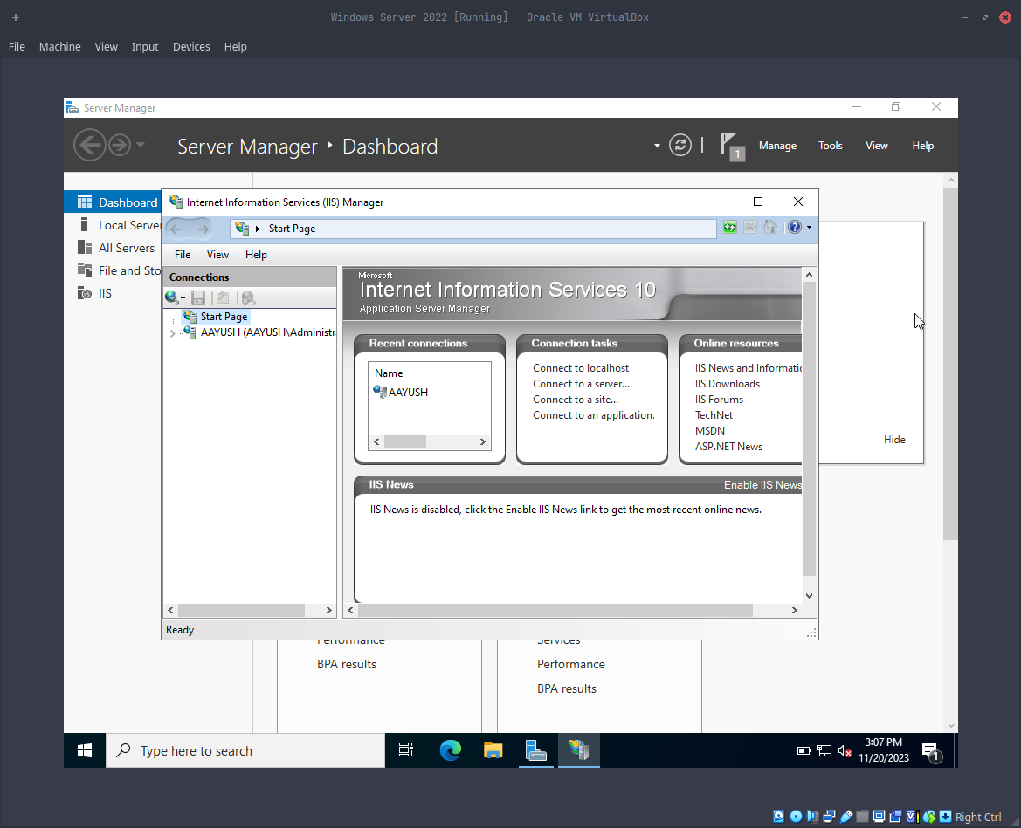
This will now open the server manager dashboard and now we can start to configure the ISS manager.
Figure 20 ISS manager
On the left-hand side under the connections tab, we can see that there are two options at first one is the start page and the other is the server’s name with the current logged in account, for me I was logged in using the Administrator account and my server’s name is AAYUSH. Now we have to click the blue arrow below the server’s name and right-click on the sites folder.
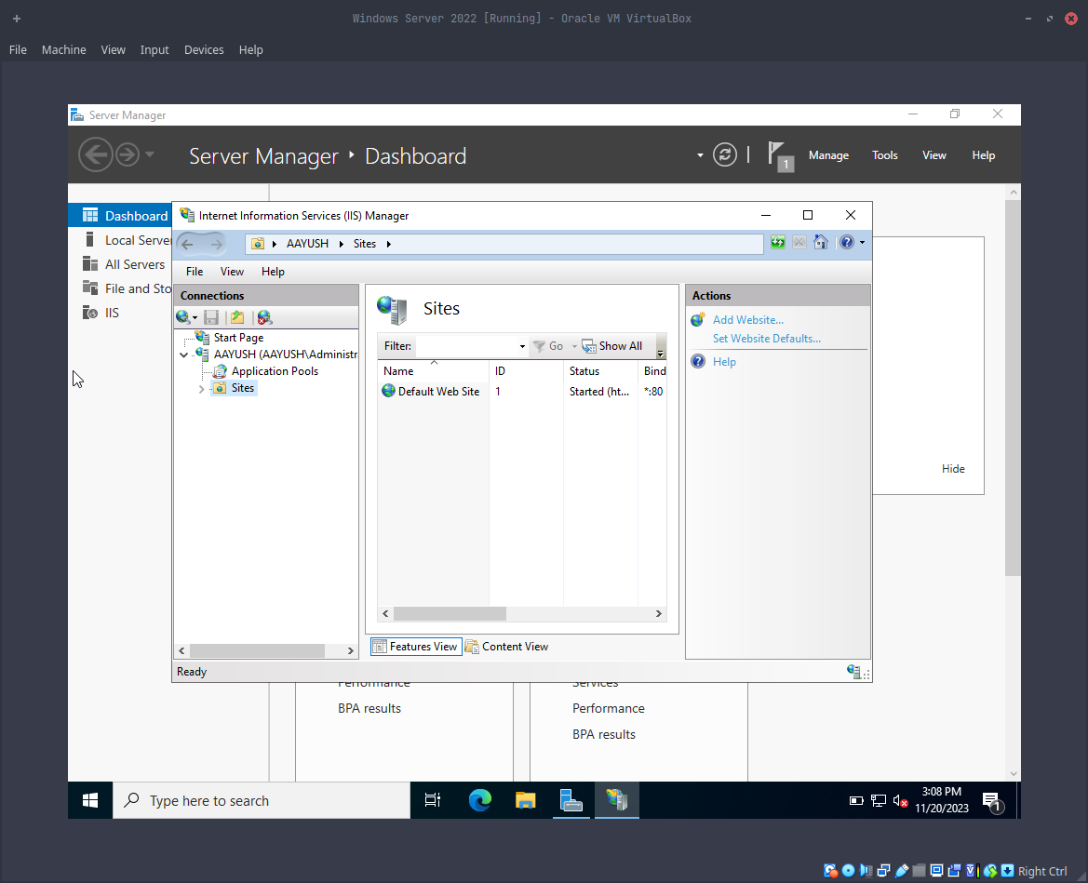
Figure 21 Selecting the Sited folder.
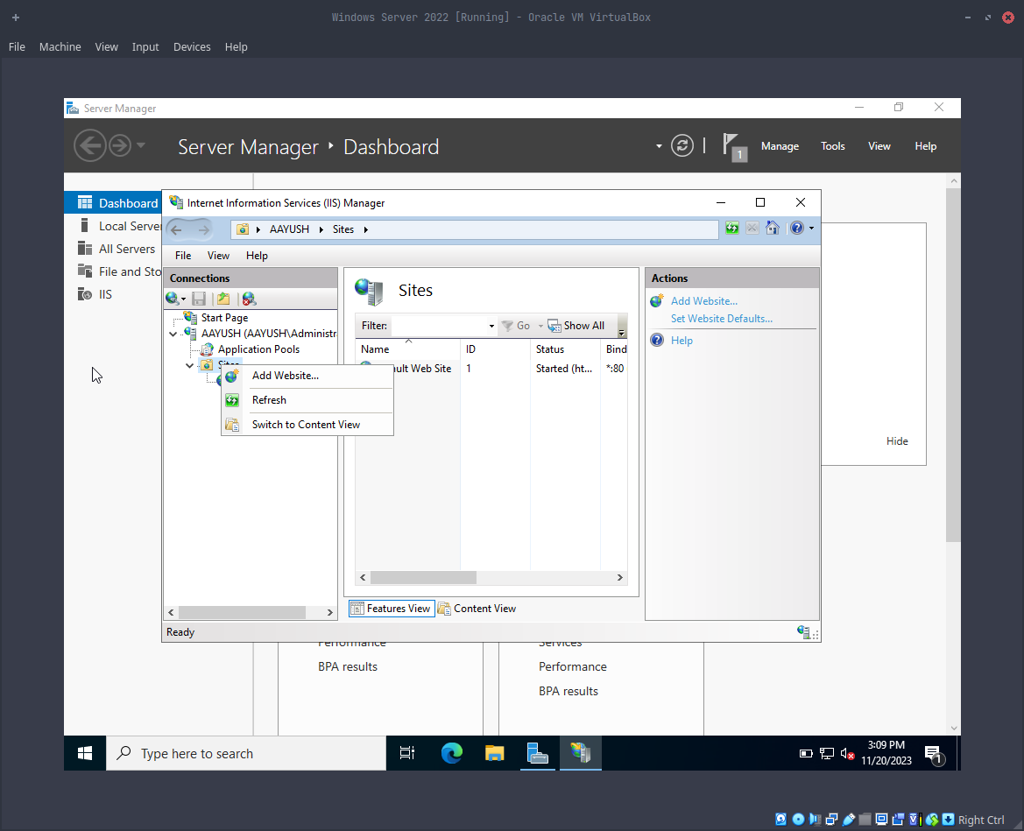
After that now we have to click on the add website button and a new window will appear.
Figure 22 Clicking on Add Website icon.
Now the final step is to enter the values in the window below.

Site Name: Give your website a unique name.
Physical Path: Select the folder where your website files are located. This is the directory on your server where the website's files are stored.
Host Name: Specify a hostname for your website.
Type: http.
Ip address: I have set it to All Unassigned.
Port: 80 which is default for http.
Figure 23 website configuration.
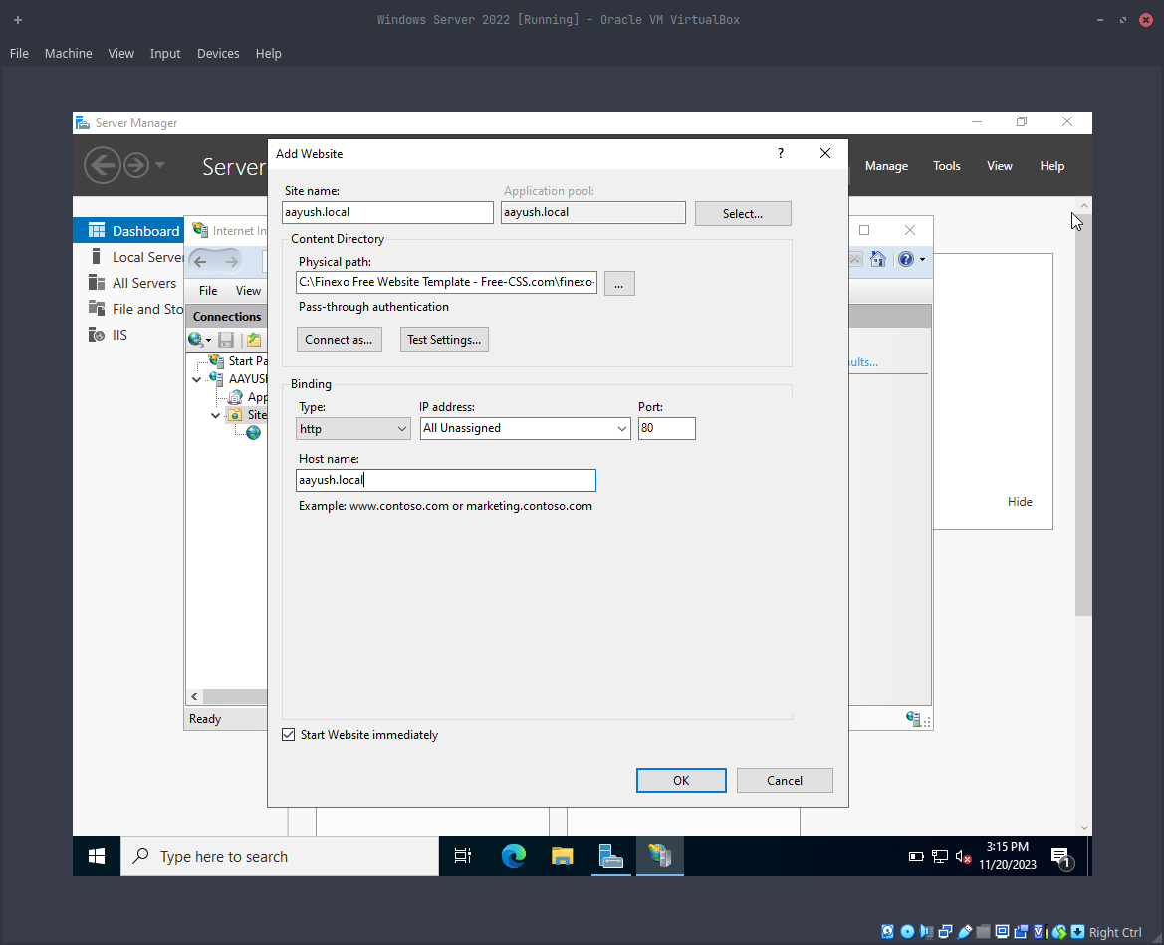

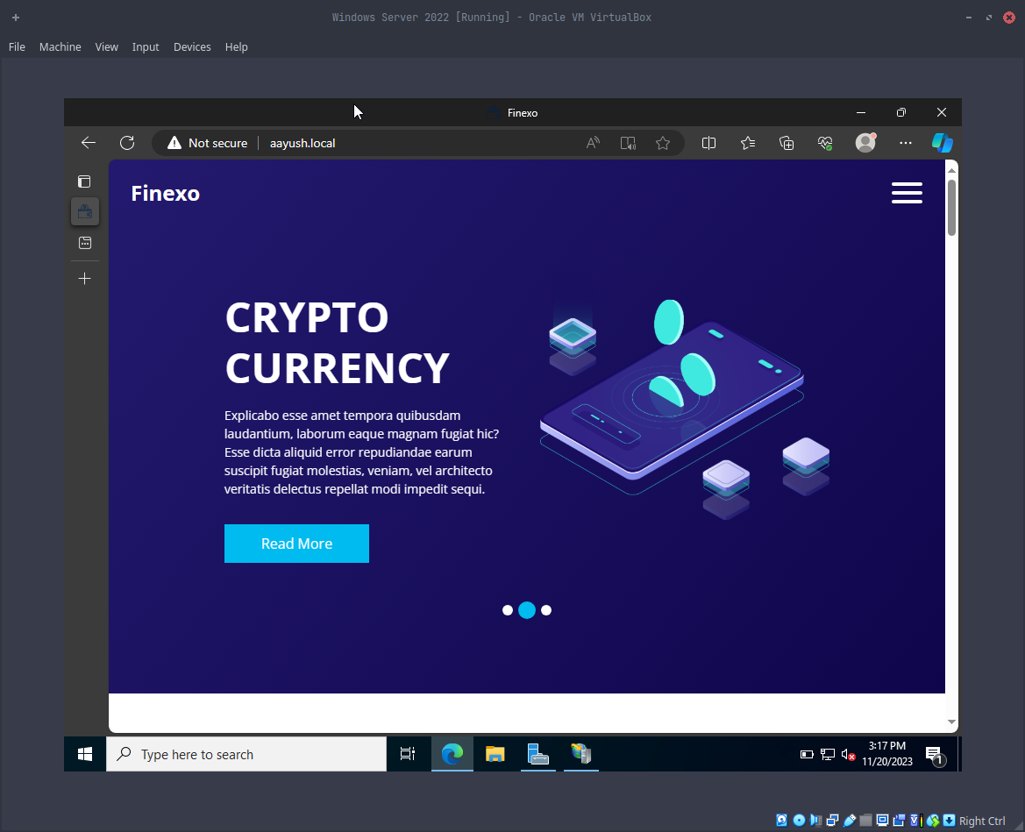
Now with the basic configurations done now all that’s left is to check if our website is up or now to do that, we can simply open the web browser and type the host name we have set for me it is Aayush.Local and the webpage will appear.
Figure 24 final testing.

1.7 Conclusion
We've successfully set up our Windows Server 2022 to host a basic static website. From downloading files to configuring server roles, each step was essential. The tools we used, like the Server Manager Dashboard and IIS Manager, made things easier. Now, we have a solid foundation to explore more and expand our web hosting skills on Windows Server 2022. This process not only taught us about server setups but also showed us how to deploy a website smoothly.

